The Integrative Cancer Epidemiology Programme
Towards improved causal evidence and enhanced prediction of cancer risk and survival

Are you interested in cancer research? Would you like to be part of a group and work with leading cancer researchers to shape the future of cancer prevention?
Background:
The University of Bristol have been funded by Cancer Research UK to study cancer prevention for the next 5 years.
This Programme of cancer research will contribute towards developing new ways to prevent, detect early, and treat cancers. This work is coordinated by the University of Bristol, with partnerships with the International Agency for Research on Cancer (IARC/WHO); The University of Exeter; McGill University, Canada; the University of Ioannina, Greece; and the Quadram Institute.
Your role will include:
Advising the research team by sharing your viewpoints and concerns of patients, carers and members of the public affected by cancer. This will help the programme: decide which research questions are of greatest importance to patients and the public; develop measures to prevent and treat cancer; publicize the findings so patients and the public can benefit from them; and more.
You will be fully supported by the Programme PPI specialists who will facilitate group discussions and other feedback mechanisms to ensure your views are captured and communicated effectively.
We are planning an online information session on 27th April which will be open to all who are interested. There will be an opportunity to learn more about the ICEP Programme and PPI work, and a chance to ask questions. For information please contact alison.denny@bristol.ac.uk (ICEP Programme Manager).
For further details of the Programme please see the website: https://www.bristol.ac.uk/integrative-epidemiology/programmes/icep/
We have also include the Terms of Reference for members of the User Reference Group below.
To register your interest please complete the attached short Expression of Interest form, and submit this to: alison.denny@bristol.ac.uk (ICEP Programme Manager).
We plan to meet with applicants, via an online meeting, to discuss their suitability and answer any questions. If you are shortlisted, we will invite you to an online interview on 10th, 12th or 21st May 2021.
The final deadline for applications is 17th May 2021.

Integrative Cancer Epidemiology Programme
Patient and Public Involvement User Reference Group
Terms of Reference
January 2021

Programme Leads: Richard Martin; Caroline Relton (University of Bristol)

Description of the User Reference Group Member’s Role
Post | Patient and Public Involvement User Reference Group (URG) member of Integrative Cancer Epidemiology Programme (ICEP).
Duration | Oct 2020 – Sept 2025
Expenses | Payment and expenses for time and travel will be paid according to INVOLVE guidelines
Training / Induction | Training about the Programme and being a member of the URG group will be given at the meetings

The Cancer Research UK Integrative Cancer Epidemiology Programme (ICEP)
A group of leading researchers has been funded by Cancer Research UK to run the Integrative Cancer Epidemiology Programme for the next 5 years.
This work is being led by the University of Bristol, with partnerships with the International Agency for Research on Cancer (IARC); The University of Exeter; McGill University, Canada; The University of Ioannina, Greece; and the Quadram Institute.
The start date for the work is 1st October 2020 and the end date is 30th September 2025. The Programme builds on previous work undertaken between 2015 to 2020.
ICEP uses pioneering statistical methods and genetic data on tens to hundreds of thousands of people to provide high quality information on:
- New causes of cancers.
- What factors influence a cancer to progress.
- New ways to predict who will develop or die from cancer.

- New ways to prevent cancer and its progression, including promoting changes to lifestyle (e.g. increasing physical activity) and finding new drugs to prevent or treat cancer.
The work will contribute towards developing new ways to prevent, detect early, and treat cancers, as well as pointing prevention measures and treatments to those most at risk.
The Programme focuses on cancers that are common, are diagnosed late or have poor survival rates, including bowel (colorectum), brain (glioma), breast, head and neck, kidney, lung, ovarian, pancreatic and prostate cancers.
Further information about the programme can be found on our Website: https://www.bristol.ac.uk/integrative-epidemiology/Programmes/icep/

The Programme of work is sub-divided into 4 Work-Packages and will do the following:
- Work package 1: Identify new, potentially modifiable factors that cause cancers to develop and progress, and find new drugs, through analysis of very large studies in populations using existing data from many sources.
- Work package 2: Understand the biological mechanisms by which things we are exposed to cause cancers to develop and progress.
- Work package 3: Identify new ways to detect cancers early, so we can screen for them, and ways to predict which cancers are the most aggressive.
- Work package 4: Use the findings to develop ways to prevent and treat cancers.

The Programme’s research is conducted under 6 themes, outlined in the diagram below:

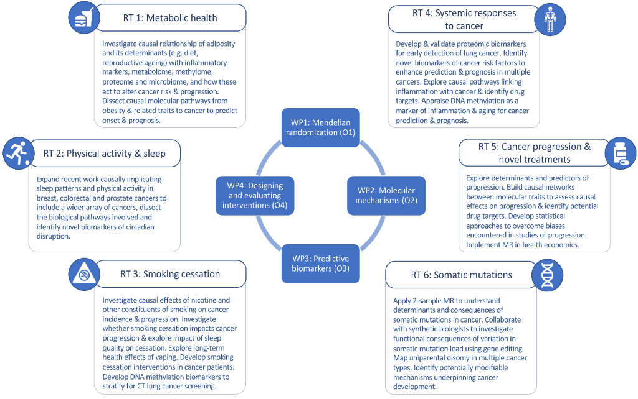

What we mean by Patient and Public Involvement (PPI)
We understand the term patient and public involvement as one that describes involving patients and members of the public in health research. When we use the term patient and public, we include people affected by cancer:
- Patients and carers living with and beyond cancer;
- Potential patients or members of the public;
- People who use health and social care services for people with cancer;
- People from organisations that represent people living with and beyond cancer.
When we use the term involvement, we use the INVOLVE definition, which defines “public involvement in research as research being carried out ‘with’ or ‘by’ members of the public rather than ‘to’, ‘about’ or ‘for’ them”.

Rather than use the terms person affected by cancer or user, we prefer to use the term research partner which, we feel, better reflects the role of people affected by cancer and service users in our research activities.
Membership of the User Reference Group
Membership of the User Reference Group (URG) will be made up of patients, carers and members of the public who are affected by cancer (either because they have cancer or know people close to them with cancer) and have an interest in population research. Other members of the ICEP research team will attend the URG meetings, as required. There will be up to 10 members in addition to the Programme PPI Strand leads (Lesley Turner and Helen Bulbeck), of around 5 people with cancer and 5 carers/members of the public. We will seek to include, in particular, people with cancers of the lung, brain and prostate, and obesity related cancers like cancers of the colon or breast.
The URG will be chaired by the Programme PPI Strand leads who will be involved in setting the agenda with the research team, focusing the structure of the meeting, and checking minutes prior to circulation.
Purpose of the URG
The URG will act as a way of providing the viewpoints and concerns of patients, carers and members of the public affected by cancer. The URG will work with researchers on the ICEP Programme and offer advice and support on areas such as:
- Prioritising research questions.
- Co-developing potential interventions in Work Package 4, and helping draft all participant facing information and consent forms within research that involve recruiting new participants.
- Risk communication and understanding people’s perception of risk.
- Dissemination (eg writing lay summaries, contributing to publications and policy documents, contributing to the content of videos and animations to explain the work).
- Promoting the need for an improved evidence-base in prevention in all its forms (primary, secondary and tertiary)
- Inputting into future grant applications.
- Inputting into training for researchers into the value and roles of PPI in research.
The main duties will involve having the time and confidence to read documents about the research and being prepared to talk about the views of people affected by cancer at the URG meetings without speaking for one group above others.

There will be a major focus on training to increase the knowledge of PPI for staff and students across the Programme. Knowledge gaps will be identified, and opportunities will be provided to address these gaps.
All members of the URG will bring their own individual expertise. Research partner members will use their knowledge and experience to work with the research team in making sure that the research remains in tune with the concerns and needs of patients and the public.
This URG is not a support group, pressure group or a representative body for research partners but URG members should act in an advisory capacity to the research Programme.
Research partner members will take a broad view of a range of study areas and research methods and have the confidence and experience to take an active part in the URG meetings.
Attendance at all URG meetings is desired. Meetings may be virtual or face to face. Communication between meetings will take place by phone/zoom calls and e-mail.
Main Responsibilities
1. To attend URG meetings: URG meetings will take place approximately twice a year over the course of the ICEP Programme, with the first meeting being in 2021, and the timing of the subsequent meetings arranged between URG members. It is likely that any in-person meetings will be held in Bristol. There will be up to 10 members appointed. At the meetings URG members will be asked to take part in discussions and make sure that a wide range of issues for people affected by cancer (rather than individual or only researcher viewpoints) are discussed, and to make sure that the final decisions take into account issues of concern to people affected by cancer overall.
2. To deal with the paperwork of the URG: URG members may be required to read paperwork sent out in advance of a meeting. They may also be asked to give their opinion on documents sent out between meetings.
3. Confidentiality: Membership of the URG includes respecting the confidential nature of the URG discussions and documents. Any information associated with the research should not be discussed with anyone outside the ICEP Programme.
4. Ownership: Members of the URG agree that the research study is owned by The University of Bristol, but that the contributions of the URG members to this study will be acknowledged in any resulting presentations and publications.
5. Payment: Members of the URG will be eligible for payment for meeting attendance and work done for the ICEP Programme and their expenses, for example travel, accommodation costs etc., reimbursed in line with INVOLVE guidance:

(http://www.invo.org.uk/posttypepublication/involvepolicy-on-payments-and-expenses-for-members-of-the-public-including-involve-groupmembers-february-2016/)

Guidelines for working together in the URG
All URG members bring their own individual expertise and experiences and will work in active partnership with each other with mutual respect for all members.
In all meetings members will agree that all those present will follow the standards below:
- Confidentiality will be agreed and respected.

- There will be respect for each person’s opinion and point of view.

- We will be non-judgmental, and sensitive to each other’s experiences.

- All experience will be valued.

- One person will speak at a time and be offered the respect of being listened to.

- Everyone will be given the opportunity to take part.

- We will support and be honest with each other.

- If anything is not clear it is ok to ask, and it will be made clear.

- We can disagree with each other, but this should be done with respect and as above.

Personal Experiences and Qualities for Members of the ICEP User Reference Group
Essential
- Affected by cancer (either because they have cancer or know people close to them with cancer).
- Interest in research into prevention and treatment, including behavioural interventions such as promotion of healthy lifestyles.
Experience
- Direct or indirect experience of cancer services/research
- Committee/Group working experience.
- Links with user networks, partnership groups.
Special Skills
- Willingness to get to know and use medical and research language.
- To keep up to date with current research issues in this Programme.
Specialist knowledge
- Knowledge of user point of view.
- To have an understanding of research.

Personal qualities
- Good at talking about thoughts, feelings, or information to another person.
- Able to listen to others and express own views about service user concerns in discussions.
- Self confidence in a mixed group of professionals and service users.
- Able to respond to challenging tasks.
- Experience of receiving agenda papers and preparing for meetings.
IT, computers and the internet
- Familiar with email and the internet and (ideally) virtual meetings platforms
- Familiar with social media

