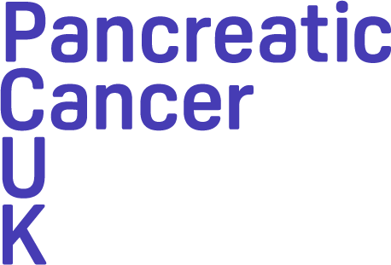
Interdisciplinary Treatment Grants
2024-25
Letter of Intent Template

Background
Pancreatic Cancer UK have launched a new ‘Interdisciplinary Treatment Grants’ funding scheme. The aim of these grants is to fund pioneering, collaborative projects that improve our understanding of how to effectively treat pancreatic cancer with a more integrated and holistic approach. To achieve this, the grants are designed to kick-start or formalise interdisciplinary collaborations, enabling researchers to work together from different disciplines to improve current treatments or find new therapeutic targets and approaches. Funding of up to £330,000 for a duration of up to 3 years is available. For further information, including eligibility, remit and the application process, please see the Full Application Guidance and FAQ documents.

Letter of Intent guidance
The submission of a Letter of Intent is the first, and compulsory, step to applying for the Interdisciplinary Treatment Grants. The purpose of this is for applicants to have an opportunity to clarify their ideas and seek advice from Pancreatic Cancer UK’s Research Team, ensuring the eligibility criteria of the funding call has been met before embarking on a full application.

Please don’t include citations within the Letter of Intent, these will be requested if you are invited to the full application stage. It is not necessary at this stage to have a fully formed proposal nor to have secured the required interdisciplinary collaborations. The Pancreatic Cancer UK Research Team may be able to help identify and liaise with new connections but making those collaborations will ultimately be the responsibility of applicants.
The Letter of Intent can be submitted any time. However, we advise applicants to do this as soon as possible in order to leave sufficient time to complete the full application. Please send the Letter of Intent as a PDF file (maximum 3 pages long, minimum size 10 font) to the Pancreatic Cancer UK Research Team at research@pancreaticcancer.org.uk. The Research Team will be in touch regarding your submission within 5 working days.

Letter of Intent Template
The letter should include:
- Main applicant details, and details of any confirmed or proposed co-applicants and/or collaborators.
- How your proposed work aims to tackle a core challenge in treatment research and aligns with the ‘Treat Better’ arm of Pancreatic Cancer UK’s research strategy.
- How your proposed work is interdisciplinary, indicating what co-applicants or collaborators will bring to this programme and why this collaboration will uniquely help you to realise the aims of the proposal.

